LAB – ASSIGNMENT #2

Administrator

Administrator

Name: Sara Riaz

Rollno : SP24-BSE-110-B

**Student Registration Form - JavaFX Application Assignment**

**Introduction**

In this assignment, we have developed a **Student Registration Form** using **JavaFX**, which is a framework for building graphical user interfaces (GUIs) in Java. The form collects personal information from users, such as **Name**, **Father’s Name**, **CNIC**, **Date of Birth**, **Gender**, and **City**. Additionally, users can upload an image and save the entered data into a list of Person objects.

This document will explain the core components of the application, including the **JavaFX Libraries**, the layout of the form, the controls used, and the functionality implemented.

**Imports Used in the Code**

Below are the **import statements** in the code, with explanations of their purpose:

**JavaFX Imports:**

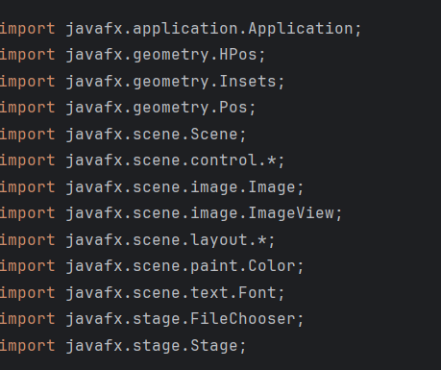

**Standard Java Imports:**

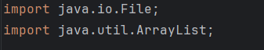

**Main Application:**StudentRegistrationForm

**JavaFX Application Structure**

The application extends the Application class and overrides the start method to set up the user interface.

**Stage and Scene Setup**

In the start method, the primary stage (Stage) is set up with a title, and a scene is created with a specified size (900x600). The scene is set inside the stage to be displayed to the user.

Java

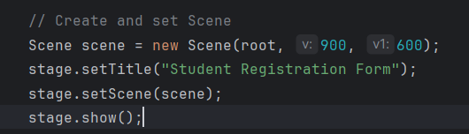

**Form Fields:**

The form contains multiple fields that users can interact with:

1. **Text Fields:**
   * **Name**, **Father's Name**, and **CNIC** are text input fields where the user can enter their information.
2. **Combo Boxes:**
   * **Gender** and **City** are dropdown lists, allowing the user to select an option.
3. **Date Picker:**
   * A **DatePicker** is used to select the **Date of Birth**.
4. **Buttons:**
   * **Save** button: When clicked, it collects the entered data and saves it as a new Person object.
   * **Upload Image** button: Opens a file chooser to select an image, which is then displayed in the UI.

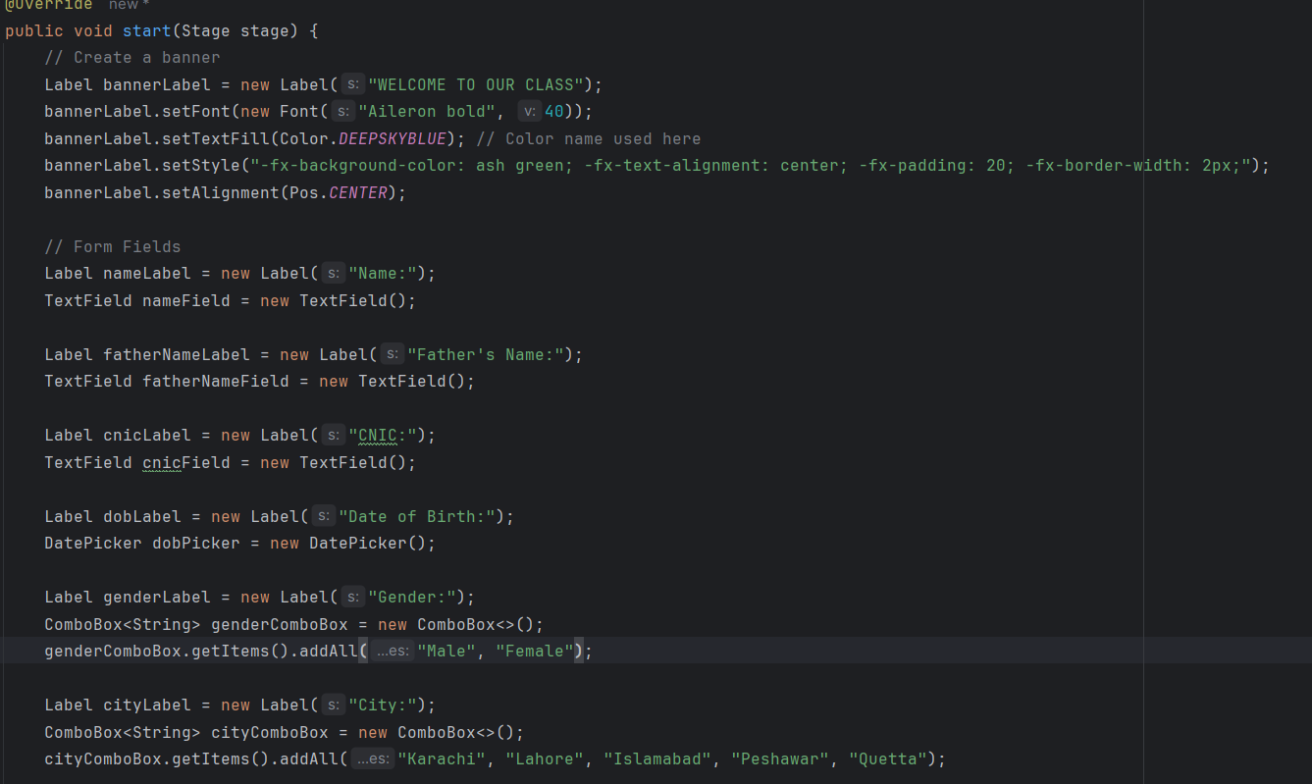

LayOUT:

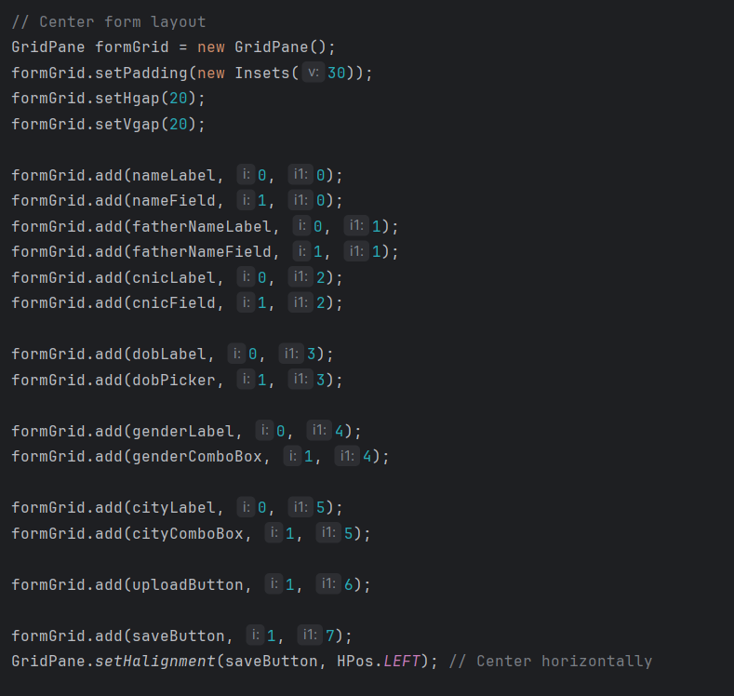

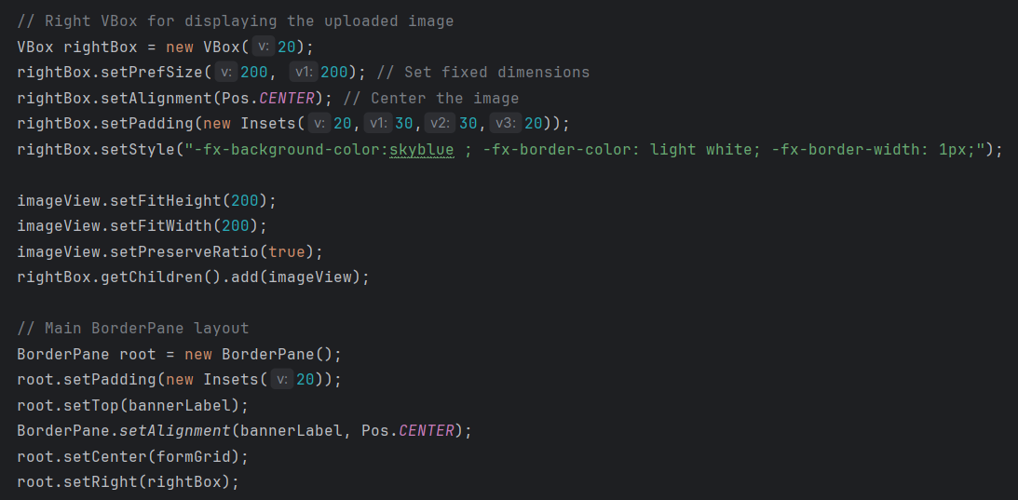

**Event Handling**

Event handling is crucial in making the application interactive. The saveButton and uploadButton have associated event handlers:

1. **Save Button Handler**:  
   This handler collects the entered information from the form fields, creates a new Person object, and adds it to the personList array.

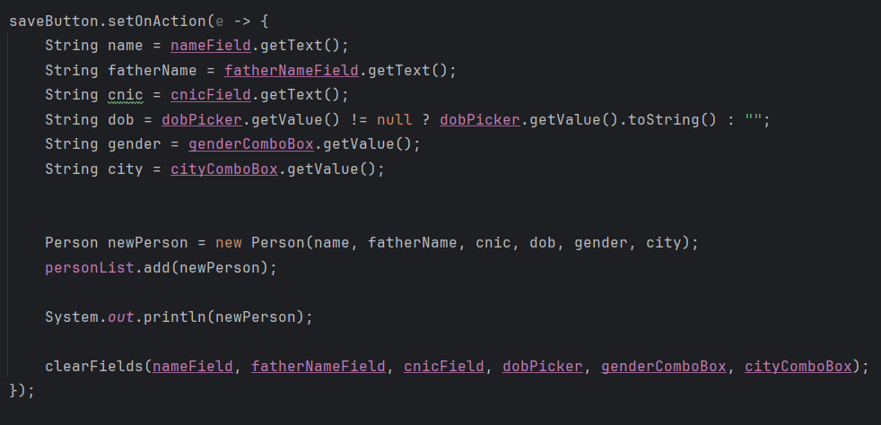

1. **Upload Button Handler**:  
   The file chooser dialog is opened when the user clicks the "Upload Image" button. The selected image is displayed inside an ImageView.

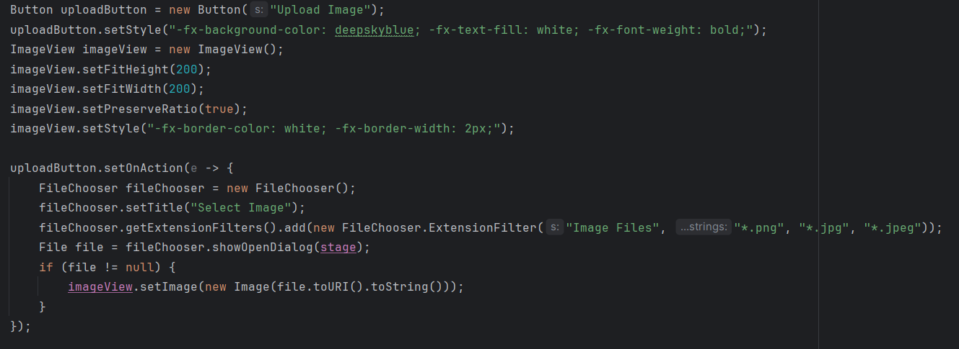

**Person Class**

The Person class is a simple data model used to represent a person. It contains attributes like name, fatherName, cnic, dob, gender, and city.

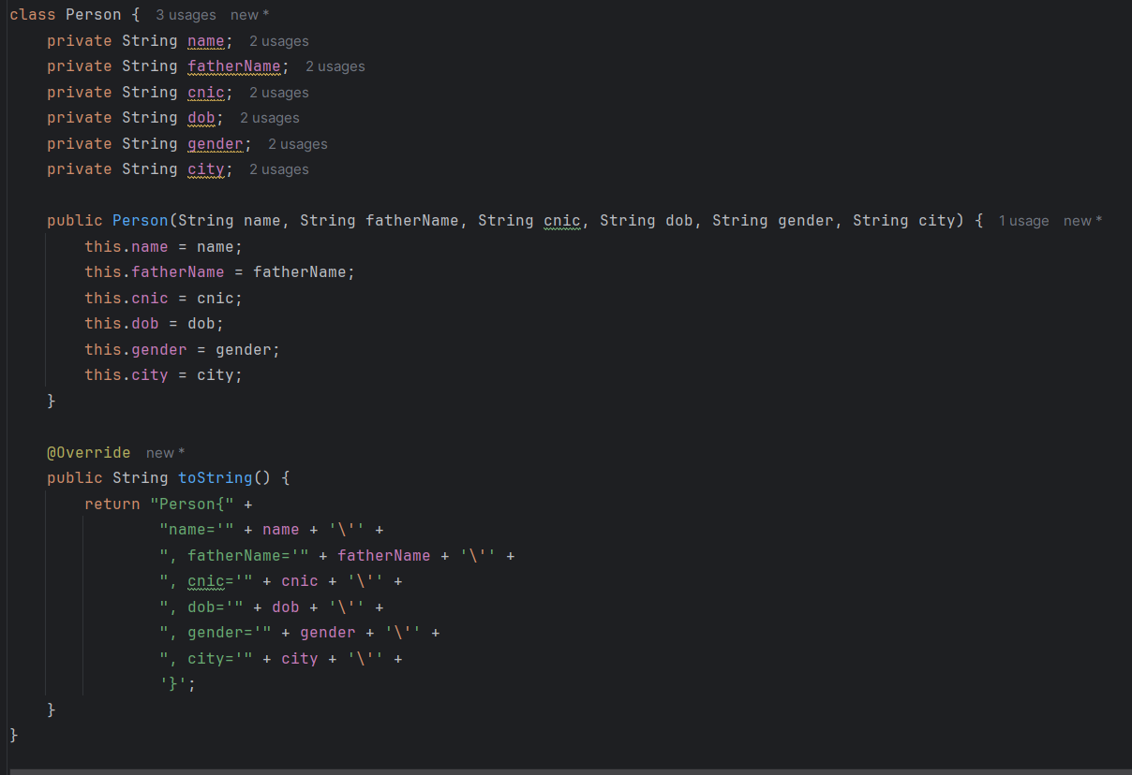

**Conclusion**

This JavaFX-based **Student Registration Form** provides an interactive GUI for entering personal information. It demonstrates basic form handling, event-driven programming, and file operations in JavaFX. The use of layout managers like GridPane and VBox, alongside event handling for buttons and file selection, makes it an effective and user-friendly application.

OUTPUTS:

Below are given outputs and save details:

